QUESTION 1- ELEMENT LIST

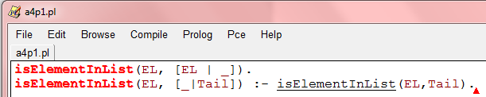

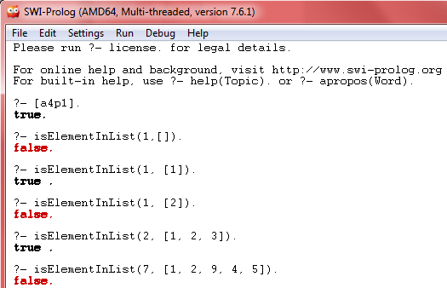

QUESTION 2-MERGE LISTS

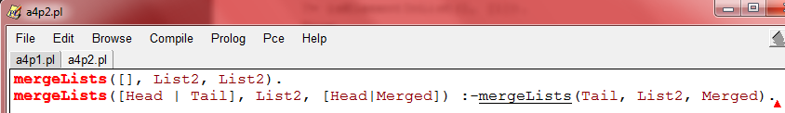

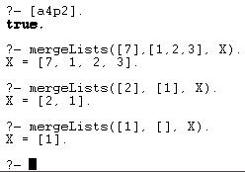

QUESTION 3-REVERSE LIST

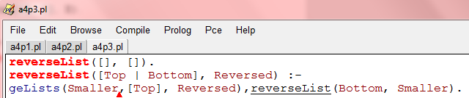

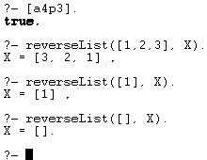

QUESTION 4- INSERT ELEMENT INTO LIST END

